03 Map of Washington DC – Mark the places mentioned in I Spy 108.07.09
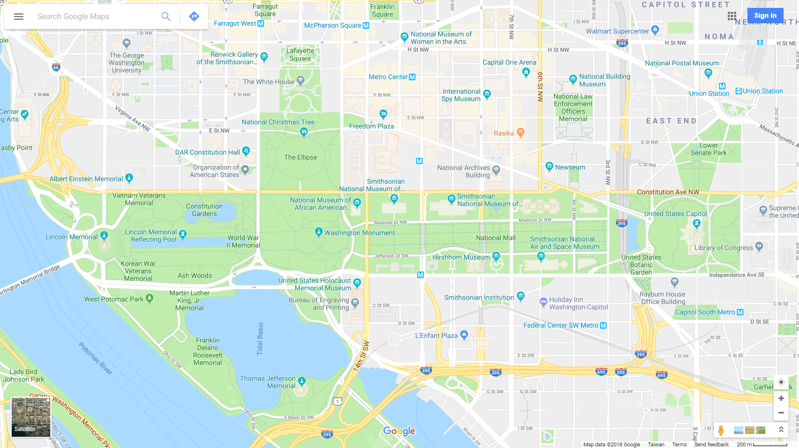

Official Tourism Site of Washington DC | Washington DC Sightseeing Tours | TOURIST MAP IN PDF
https://washington.org | https://goo.gl/xbndTn | https://goo.gl/ANBdca
Plan your one-day tour in Washington DC. Class: No.: Name:
At least 4 sites. The plan should include: 1. route 2. length of stay 3. transport 4. dining 108.07.09

